**TWP BREAKFAST MENU**

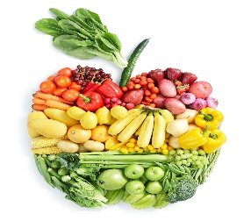

[This Photo](http://www.emptycagesdesign.org/eat-2017-a-whole-bunch-of-exciting-courses-happening-this-year/) by Unknown Author is licensed under [CC BY](https://creativecommons.org/licenses/by/3.0/)

**Middle School and High School**

Cold Items

Pop Tarts

Cereal Bars

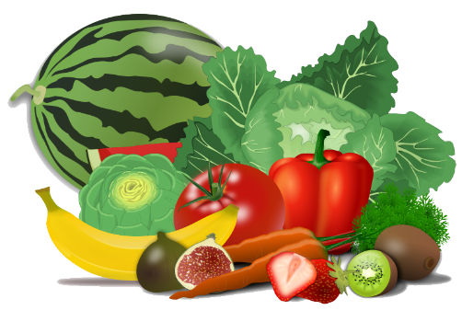

Bagels with Cream Cheese

Cereal

Assorted Muffins

String Cheese and/or Yogurt

Assorted Smoothies

Hot Items

Assorted Hot Items Available Daily

Milk, Juice, and Assorted Fruits and Vegetables Offered Daily



[This Photo](http://commons.wikimedia.org/wiki/File:Apple-book.svg) by Unknown Author is licensed under [CC BY-SA](https://creativecommons.org/licenses/by-sa/3.0/)